**[CSS652 Networks Lab]**

Name: Rahul Ranjan

Roll No: 20CS8016

**Lab 1**

Q. Create a Server – Client connection.

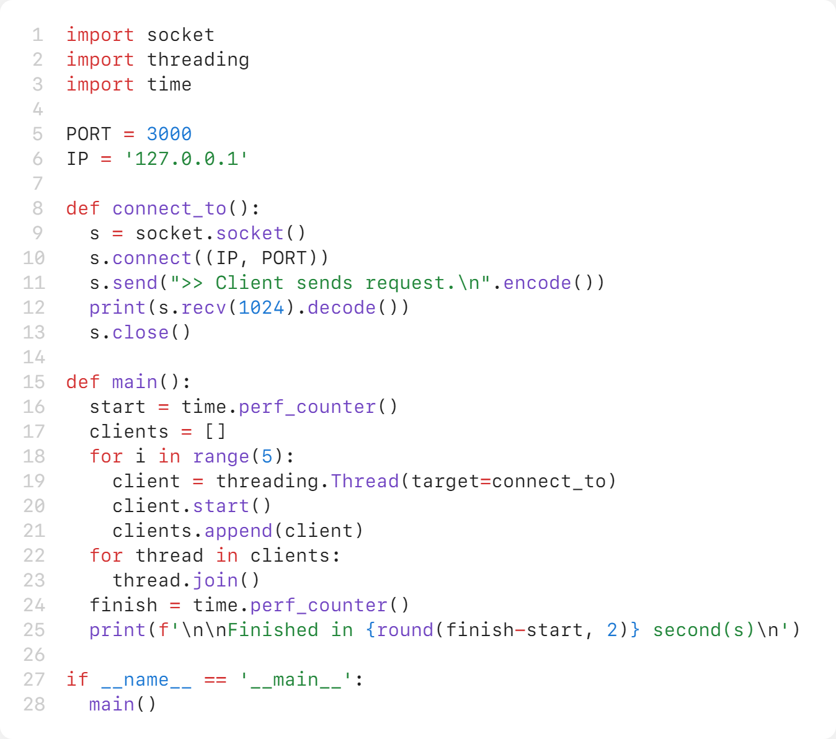**>>** client.py [multithreaded client requests]

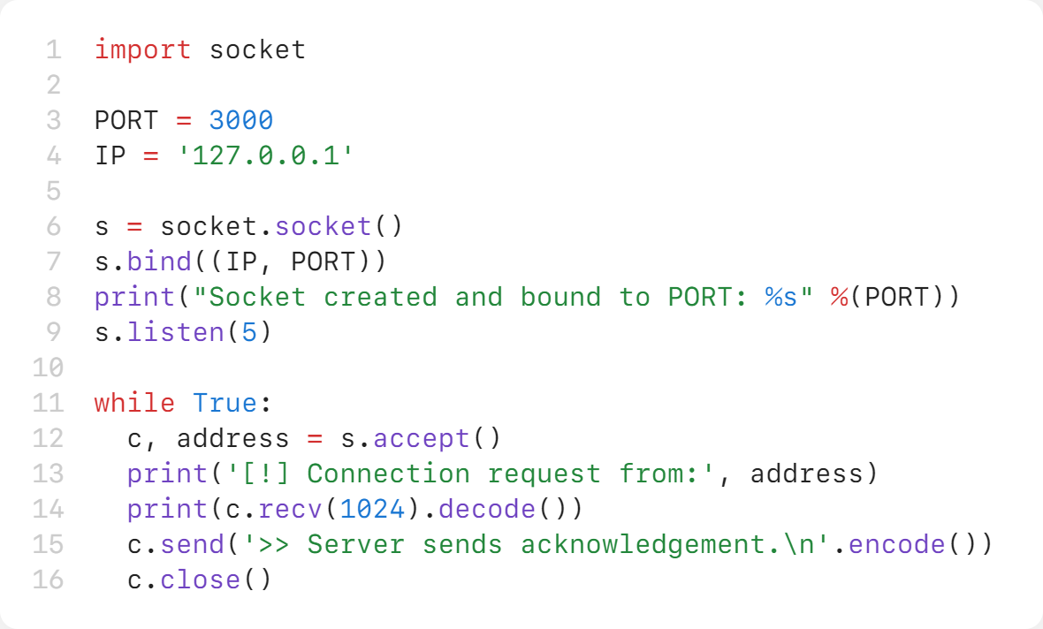**>>** server.py

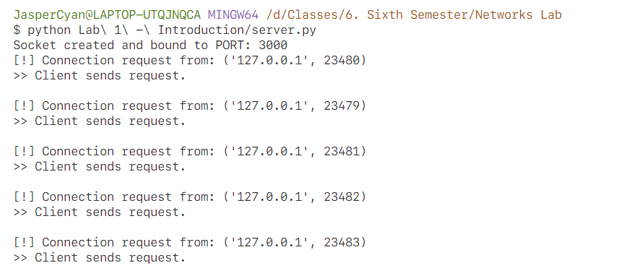**>>** Runtime [Server Logs]

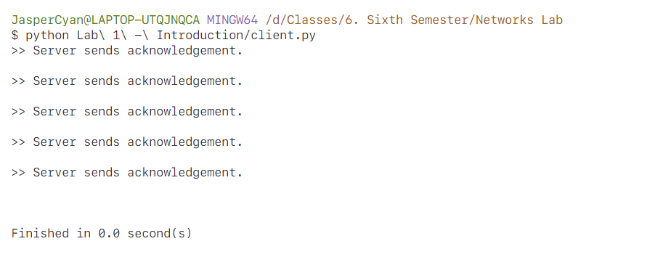**>>** Client Side